7.Interfacing MFRC522 RFID board with ESP 32.(Practical)

MFRC522 RFID Module

RC522 RFID Modules work on 13.56MHz which is based on the MFRC522 controller which is designed by NXP Semiconductor.
The RC522 module supports SPI and I2C communication protocols. Here we are using the SPI communication Interface with the ESP32 board.
This module operates on a +3.3V/13-26mA Power Supply. The RFID reader automatically goes to power save mode after its operation is complete and it takes a 10-13mA standby current.
We can use this RFID for inventory management, attendance system, access control system, etc.

RFID RC522 Hardware Connection with ESP32
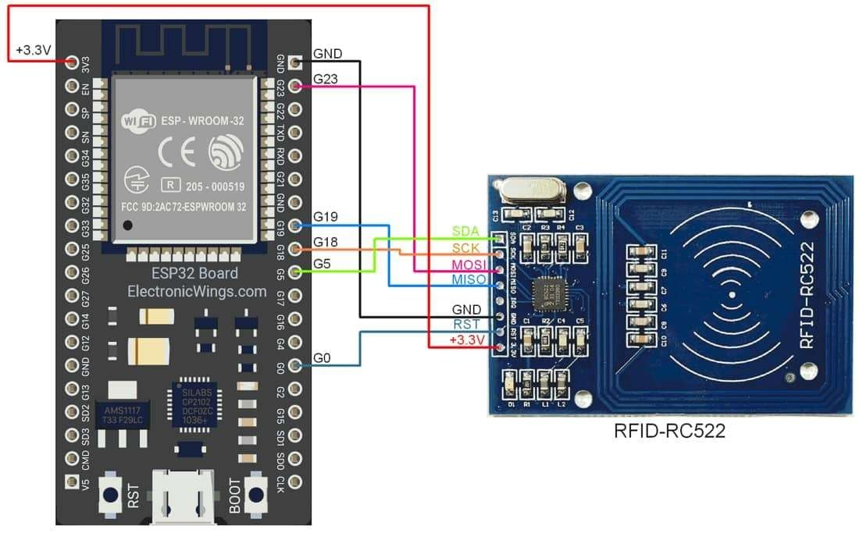
RFID RC522 interfacing with ESP32

Sr No | RFID RC522 Pins | ESP32 Pins
1 | VCC | +3.3V
2 | RST | D0
3 | GND | GND
4 | MISO | 19
5 | MOSI | 23
6 | SCK | 18
7 | SS/SDA | 5

Read the MFRC522 RFID using ESP32
Here we are using MFRC522 libraries to read the RFID tag example. We will need to install the MFRC522 library using the Arduino Library Manager.

Open the Arduino IDE and navigate to Sketch ► Include Library ► Manage Libraries…
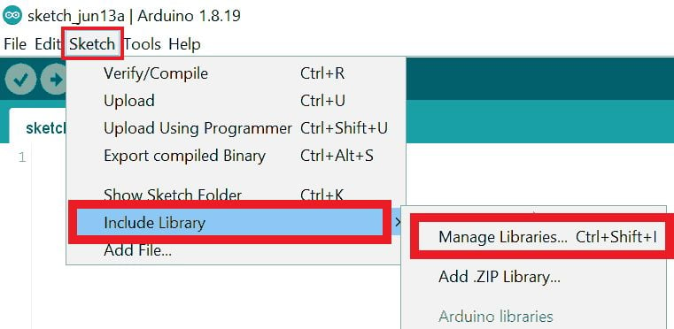

The library Manager window will pop up. Now enter MFRC522 into the search box and click Install on the MFRC522 option to install version 1.4.10 or higher.
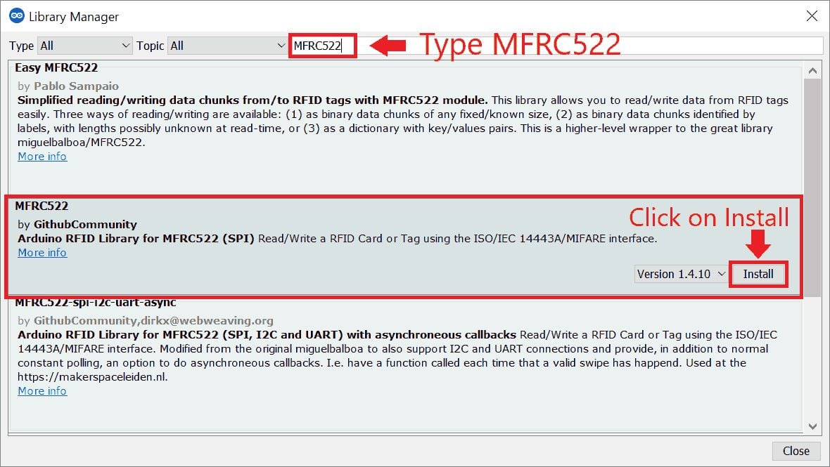

Now open the example of MFRC522. To open it navigate to File ► Examples ► MFRC522 ► ReadNUID
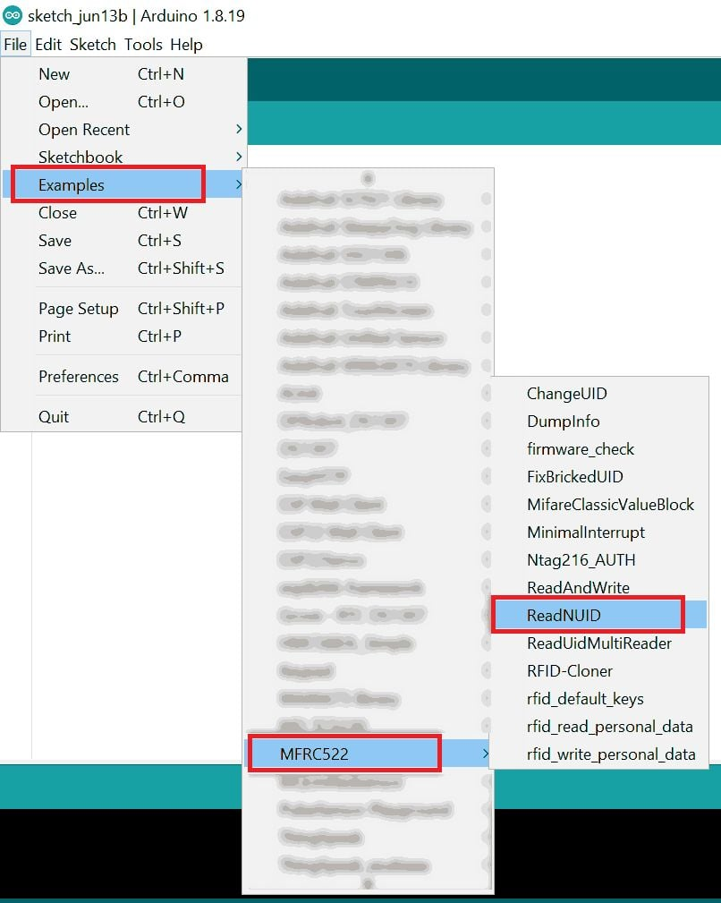

Note: When you open the code, please change the SS and RST pin numbers in the code as shown below.
#define SS_PIN 5

#include <SPI.h>//https://www.arduino.cc/en/reference/SPI
#include <MFRC522.h>//https://github.com/miguelbalboa/rfid

//Constants
#define SS_PIN 5
#define RST_PIN 0

//Parameters
const int ipaddress[4] = {103, 97, 67, 25};

//Variables
byte nuidPICC[4] = {0, 0, 0, 0};
MFRC522::MIFARE_Key key;
MFRC522 rfid = MFRC522(SS_PIN, RST_PIN);

void setup() {
//Init Serial USB
Serial.begin(115200);
Serial.println(F("Initialize System"));
//init rfid D8,D5,D6,D7
SPI.begin();
rfid.PCD_Init();

Serial.print(F("Reader :"));
rfid.PCD_DumpVersionToSerial();
}

void loop() {
readRFID();
}

void readRFID(void ) { /* function readRFID */
////Read RFID card

for (byte i = 0; i < 6; i++) {
key.keyByte[i] = 0xFF;
}
// Look for new 1 cards
if ( ! rfid.PICC_IsNewCardPresent())
return;

// Verify if the NUID has been readed
if ( !rfid.PICC_ReadCardSerial())
return;

// Store NUID into nuidPICC array
for (byte i = 0; i < 4; i++) {
nuidPICC[i] = rfid.uid.uidByte[i];
}

Serial.print(F("RFID In dec: "));
printDec(rfid.uid.uidByte, rfid.uid.size);
Serial.println();

// Halt PICC
rfid.PICC_HaltA();

// Stop encryption on PCD
rfid.PCD_StopCrypto1();

}

/**
Helper routine to dump a byte array as hex values to Serial.
*/
void printHex(byte *buffer, byte bufferSize) {
for (byte i = 0; i < bufferSize; i++) {
Serial.print(buffer[i] < 0x10 ? " 0" : " ");
Serial.print(buffer[i], HEX);
}
}

/**
Helper routine to dump a byte array as dec values to Serial.
*/
void printDec(byte *buffer, byte bufferSize) {
for (byte i = 0; i < bufferSize; i++) {
Serial.print(buffer[i] < 0x10 ? " 0" : " ");
Serial.print(buffer[i], DEC);
}
}


Exp 7 alternate

#include <SPI.h>
#include <MFRC522.h>

// Define the pins used for the RC522 module
#define RST_PIN 22 // Reset pin
#define SS_PIN 5 // Slave Select pin (SDA)

// Create an instance of the MFRC522 class
MFRC522 mfrc522(SS_PIN, RST_PIN); // Create MFRC522 instance

void setup() {
// Start the Serial Monitor
Serial.begin(115200);

// Initialize SPI bus and RC522
SPI.begin(); // Initialize SPI bus
mfrc522.PCD_Init(); // Initialize RC522

Serial.println("RFID Reader initialized. Scan a card.");
}

void loop() {
// Look for new RFID card
if ( !mfrc522.PICC_IsNewCardPresent()) {
return; // If no new card is present, exit the function
}

// Select one of the cards
if ( !mfrc522.PICC_ReadCardSerial()) {
return; // If reading the card's serial number failed, exit the function
}

// Print the UID of the scanned card
Serial.print("UID: ");
for (byte i = 0; i < mfrc522.uid.size; i++) {
Serial.print(mfrc522.uid.uidByte[i], HEX); // Print each byte in HEX format
Serial.print(" ");
}
Serial.println();

// Halt the card (optional, to stop communication)
mfrc522.PICC_HaltA();

// Stop the communication with the RFID card
mfrc522.PCD_StopCrypto1();

delay(1000); // Wait 1 second before reading again
}

7.Finding the Default SPI pins of ESP 32(Skilling)

Source Code:
//Find the default SPI pins for your board
//Make sure you have the right board selected in Tools > Boards
void setup() {
// put your setup code here, to run once:
Serial.begin(115200);
Serial.print("MOSI: ");
Serial.println(MOSI);
Serial.print("MISO: ");
Serial.println(MISO);
Serial.print("SCK: ");
Serial.println(SCK);
Serial.print("SS: ");
Serial.println(SS);
}

void loop() {
// put your main code here, to run repeatedly:
}

Output:
configsip: 0, SPIWP:0xee
clk_drv:0x00,q_drv:0x00,d_drv:0x00,cs0_drv:0x00,hd_drv:0x00,wp_drv:0x00
mode:DIO, clock div:1
load:0x3fff0030,len:1344
load:0x40078000,len:13964
load:0x40080400,len:3600
entry 0x400805f0
MOSI: 23
MISO: 19
SCK: 18
SS: 5

